# Conflict Scenario

## **Review**

### Interpersonal Conflict Management Styles

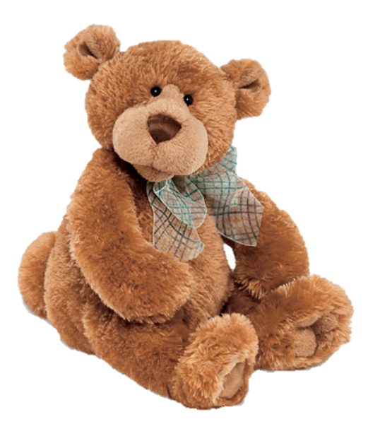

[CC 2.0 BY Matthew](https://www.flickr.com/photos/falcon1961/3304306800/)



[CC SA 3.0 Unported BY Jonathan Zander](https://en.wikipedia.org/wiki/File:Florida_Box_Turtle_Digon3.jpg)



[CC 3.0 BY Superawesomevectors](https://superawesomevectors.deviantart.com/art/Shark-Cartoon-Free-Vector-Illustration-643399222)



[CC0](https://pixabay.com/en/urban-lost-hiding-afraid-1002149/)

Low to High Concern for Other

Concern for Self

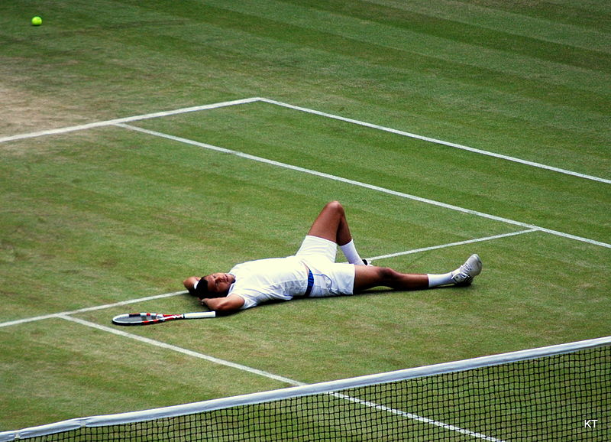

CC SA 2.0 Generic BY [Carine06 from UK](https://commons.wikimedia.org/wiki/File:Flickr_-_Carine06_-_%22I_give_up.%22.jpg)



CC 2.0 BY [Zabara Alexander](https://www.flickr.com/photos/zabara_tango/6955720271)

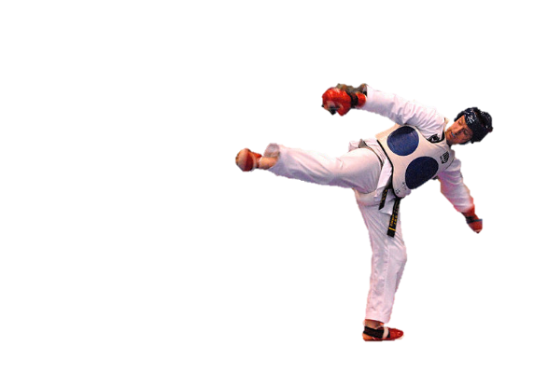

[CC0](https://commons.wikimedia.org/wiki/File:US_Army_53525_Soldiers_compete_in_Tae_Kwon_Do_tournament_for_Warrior_Country_level.jpg)

### **Interpersonal Conflict Resolution**

The following diagram shows a process that can be followed when trying to resolve interpersonal conflict.

### Listening

A considerable proportion of our communication involves listening, yet little attention is devoted to improving listening. HURIER is an acronym for tips that can be used to improve listening.

### “I” Phrases for Conflict Resolution

The “I” phrase is used during conflict resolutions to avoid attacking others. Open the conversation with a statement in first person, passive voice: “I feel … when … because … I would like …”

Adapted from (Dwyer 2012, p. 40)

## **Student Name and ID:** Jake Vanderkruk 12093426

## **Student Name and ID:** Joel Rothlisberger 12188569

## **Scenario**

Find a partner. Read the scenario below. Choose one partner to be Joe Bloggs, and the other to be Jane Doe. Together, answer the following to help prepare you for the role play.

## **Scenario: Joe did not complete a task by the deadline**

Joe and Jane are working on a report that is due today. Joe was assigned the task of writing the executive summary. Unfortunately, Joe has not completed the task.

What is the most appropriate conflict management strategy for Jane to use in this situation? (Choose one)

Compete/Force

Compromise

Avoid/Withdraw

Collaborate/Confront

Accommodate/Smooth

Why did you choose the above conflict management strategy?

Collaborate/Confront was the chosen conflict management strategy as the report is a team effort and requires work from both Jane and Joe. The other conflict management strategies would lead to shattered relations between Jane and Joe, as well as potentially leaving Jane to complete the report herself.

### **Listen and Understand**

How could Jane start the conversation?

Jane could start the conversation by updating Joe regarding her progress on the report that is due today, whilst also requesting his progress on the report. This is a reasonable way for Jane to start the conversation with Joe, as his response to his progress on the report will determine if there is a conflict.

Describe the purpose of the discussion. Describe the conflict. What questions could Jane ask to determine Joe’s perspective of the situation?

The initial purpose of the discussion is to gather Joe’s progress on the executive summary of the report. The conflict arises when Joe informs Jane that he has not completed the executive summary. Questions that Jane could ask to determine Joe’s perspective include: “Why didn’t you complete the executive summary?” “Is there a reason why you felt you couldn’t tell me sooner?”

Write sentences that features the “I” phrase, such as in the example below:

“I feel *[your feeling]* when *[their behaviour]* because *[effects on you]*. I would like *[alternative behaviour]*”.

Jane - I feel frustrated when you don’t complete your share of the report, because it puts more stress on my shoulders. I would like to see you complete your share of the report.

Joe – I feel unheard when you don’t understand my situation, because it makes me feel undervalued. I would like you to hear and understand what I am going through.

Invent a reason why Joe did not complete the executive summary by the deadline.

Joe’s daughter has been ill for the duration of the report, he was unable to complete the executive summary by the deadline because he needed to look after her.

How could Jane paraphrase Joe’s reason for missing the deadline to ensure that she understands Joe’s perspective?

From what you’ve told me, you needed to look after your daughter while she was ill, which affected your ability to finish your share of the report before the deadline.

### **Empathise**

Now that Jane understands Joe’s perspective, how could Jane empathise with Joe? Write a response that shows that Jane identifies with Joe’s emotions.

I’m sorry to hear about your daughter, I understand how hard it can be to prioritise work when there are urgent family matters.

### **Apologise**

Include an apology if it is appropriate.

Joe – I’m sorry that I didn’t communicate this to you sooner, it was unprofessional of me to leave it this late.

### **Offer Solution**

What question could Jane ask to help build Joe’s involvement with potential solutions?

“I think brainstorming ideas to get this executive summary finished and delivered on time is a great idea, is that something you would be interested in?”

Come up with a way for Jane and Joe to settle on a solution.

Jane and Joe need brainstorm to identify the best solution that accommodates both of their needs.

### **Resolution**

How could Jane resolve the conflict? Jane needs to ensure that Joe agrees. Write a response that outlines appreciation for the solution.

Jane can resolve the conflict by ensuring that both Joe and she feel heard and understood by each other to achieve better communication in current and future collaborations and finish the report together by the deadline.

Jane – “I’m glad that we have found a solution that benefits both of us, I believe we will be able to finish the report together and communicate issues more clearly in the future”

### **Reconciliation**

How could Joe reconcile the relationship and let Jane know that she is important to him?

Joe could give a physical gift such as chocolates as a gesture of gratitude, as well as communicate verbally to Jane how he feels. Such as “I really appreciate your work on the report, and your understanding of my situation.”

How can Jane let Joe know she is listening while Joe is talking?

Jane can let Joe know she is listening whilst he is talking through appropriate eye contact; non-verbal gestures and avoiding interruptions to Joe while he is talking.

What could Jane do if Joe started to withdraw from the conflict at any stage?

Jane could keep Joe attentive to the conflict by giving him the opportunity to speak, so that his needs can be heard and understood.